STAGE 3A TASK - THE UNKNOWN PRODUCT
PRODUCT NAME: BREV
MOTTO: THE MINAMALIST PRODUCTIVITY COMPANION
NAME: JEREMIAH JAPHET
SLACK ID: Jay

1. Product Interpretation
Brev is a minimalist productivity companion designed for professionals who crave structure without clutter. It merges task management, journaling, and focus tracking into one seamless, distraction-free experience. Unlike conventional productivity tools packed with unnecessary features, Brev focuses on clarity helping users prioritize, plan, and perform better through simplicity.
Its philosophy is grounded in the belief that productivity should amplify clarity, not complexity. Brev’s minimalist interface and intelligent suggestions keep users focused on what truly matters: deep work and consistent progress.

2. Research & Primary Ideation Data
The ideation process began with a quick exploratory survey of 25 professionals and students to understand their daily productivity struggles. The findings revealed three key pain points: overload of cluttered apps, lack of motivation tracking, and decision fatigue caused by complex workflows.
Through this discovery, the Brev concept emerged a tool designed to make focus feel intuitive. Early brainstorming sessions centered on creating a space where simplicity drives consistency, not pressure.

User Persona
Name: Adaeze, 27
Occupation: UX Designer
Pain Points: Feels overwhelmed by multiple productivity tools.
Goal: Wants one clean space to plan, reflect, and track progress without distractions.
Competitive Snapshot
Competitors like Notion, Todoist, and ClickUp offer excellent features but often overwhelm users. Brev differentiates itself by offering a frictionless, minimalist approach focused solely on clarity and deep work.

3. Problem Statement
In today’s digital landscape, professionals face an overload of tools promising productivity yet delivering distraction. Users toggle between task apps, note-takers, and planners, often losing time to context-switching. Interviews and surveys revealed that while users crave order, they’re drowning in complexity, from excessive notifications to feature bloat. One respondent described it best: 'I spend more time setting up my tools than actually working.'
The underlying problem isn’t a lack of tools; it’s a lack of balance. People need mental clarity, not just task tracking. Brev was designed to solve this by simplifying workflow management and emphasizing mindful productivity. It brings together the essentials: plan, reflect, and track nothing more, nothing less.

4. The Build Phase
Brev’s framework follows three key modules: Plan, Reflect, and Progress. Users start their day with a brief planner view, capture notes or reflections in a journaling panel, and visualize focus time through a progress tracker. The UX design prioritizes whitespace, calm color palettes, and intuitive icons.
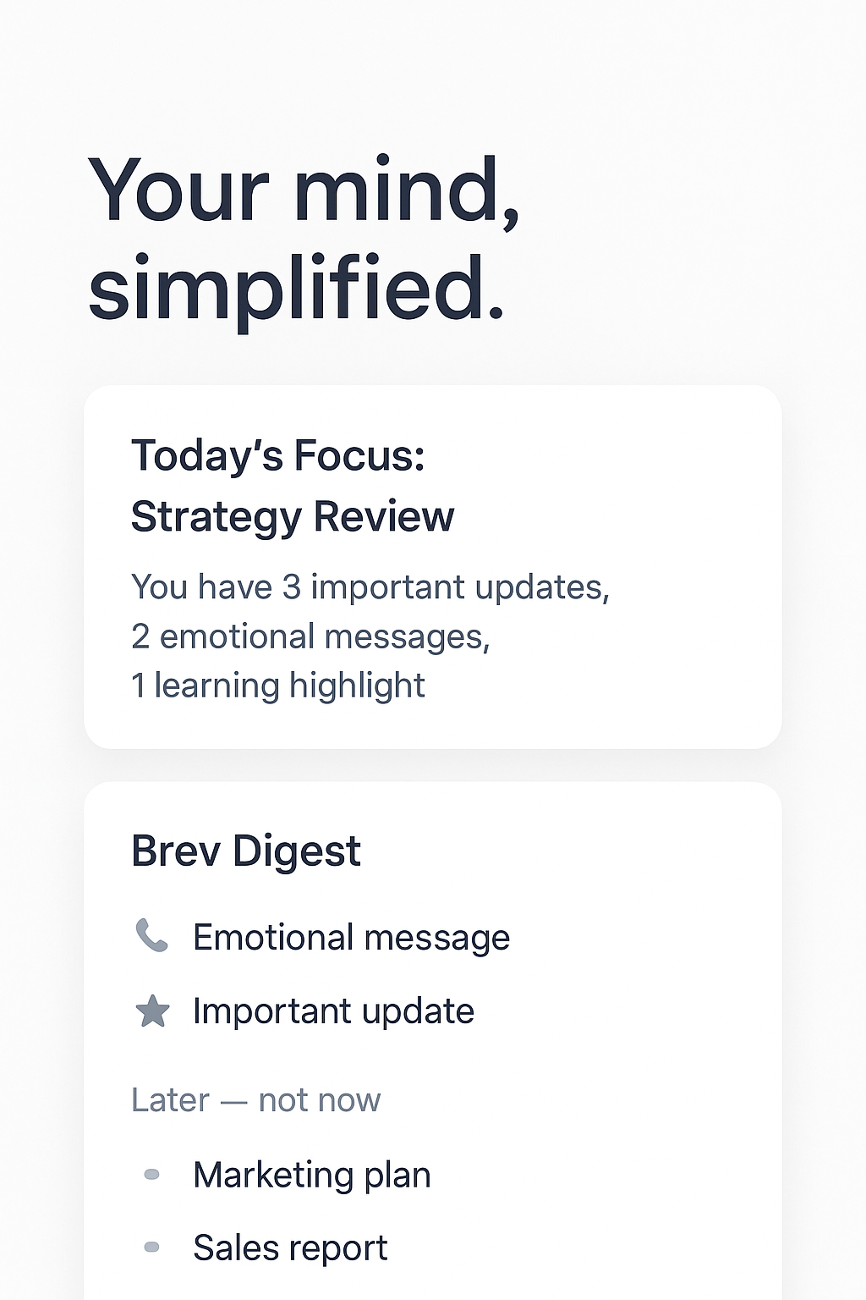
(Digital Mockup of Brev’s Minimalist Interface)
The MVP includes essential components: daily task cards, focus timer, reflection journal, and analytics overview. The backend would rely on lightweight cloud sync, while the frontend leverages Flutter or React Native for cross-platform access. Brev’s simplicity ensures scalability without technical bloat.

5. Feasibility
Technically, Brev is feasible through modern frameworks like React for web and Flutter for mobile, integrated with Firebase for real-time sync. Operationally, a lean three-person team (Designer, Developer, Product Manager) can deliver the MVP in 10–12 weeks. Business-wise, Brev could adopt a freemium model: basic planning free, advanced analytics under a paid tier.
Scalability is achievable through modular feature design, allowing future integration with calendar APIs, habit trackers, and AI-driven insights.
6. Reflection
Building Brev challenged my perspective on simplicity. At first, I struggled with the temptation to add more, more features, more visuals, more functionality. But through research and feedback, I realized minimalism is not about less, it’s about purpose. Every element in Brev had to earn its place. That shift in mindset shaped my understanding of real product thinking.
I learned that clarity is scalable, and good design is invisible when it works. This project reinforced that empathy and restraint are as important as creativity in building human-centered products.

7. Raw Artifact
Below is an early concept sketch from the ideation phase showing the structural layout of Brev’s user flow.
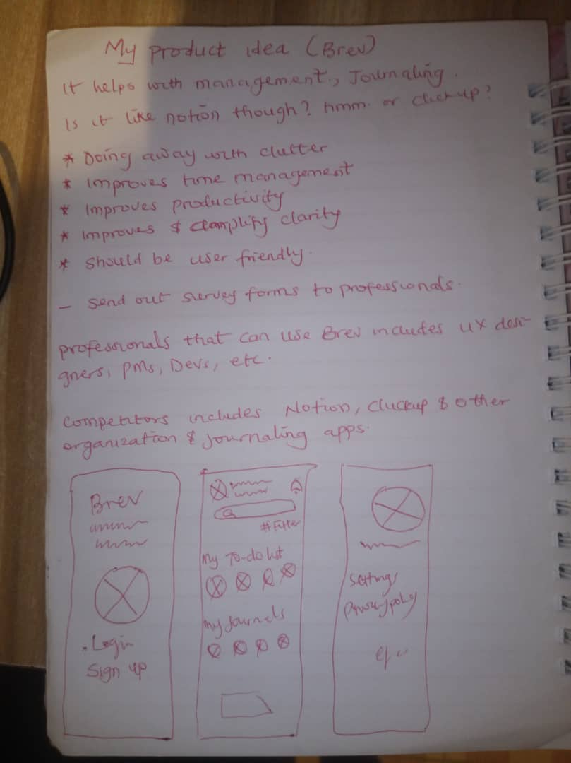
Early Sketch: Brev’s Ideation Wireframe

